
Data Analysis & Business Understanding
Week 1 Task – Exploratory Data Analysis Report

Submitted By: Tousif Khan
Registration Number: AIMLB01-2243
Internship Domain: AI & ML
Institute: ITSimplera Institute
Submission Date: 03 July 2026
Dataset Used: Online Retail II Dataset (UCI)

Table of Contents
Table of Contents 1
Objective of the Task 1
Step 1: Loading the Dataset 1
Step 2: Basic Dataset Information 1
Step 3: Missing Values & Duplicate Rows 1
Step 4: Top 10 Best-Selling Products 1
Step 5: Sales Performance by Country 1
Step 6: Monthly Revenue Trend 1
Step 7: Correlation Heatmap 1
Step 8: Outlier Detection (Box Plots) 1
Business Insights 1
Conclusion 1

Objective of the Task
A retail company wants to understand customer purchase behavior before investing in a recommendation system. Acting as a data analyst, this task involves exploring the provided dataset, identifying patterns and data quality issues, and producing a complete Exploratory Data Analysis (EDA) report that helps the company understand who its customers are, which products sell the most, and which countries generate the most revenue.
Dataset: Online Retail II Dataset — real transaction data from a UK-based online retailer covering 2009–2011, including invoices, product descriptions, quantities, prices, and customer IDs.

Step 1: Loading the Dataset
The dataset was provided as an Excel file (online_retail_II.xlsx) containing two sheets — 'Year 2009-2010' and 'Year 2010-2011'. Both sheets were loaded using pandas and combined into a single dataframe for a complete two-year analysis.
df_2009 = pd.read_excel('online_retail_II.xlsx', sheet_name='Year 2009-2010')
df_2010 = pd.read_excel('online_retail_II.xlsx', sheet_name='Year 2010-2011')

df = pd.concat([df_2009, df_2010], ignore_index=True)
print(f"Combined shape: {df.shape}")
df.head()

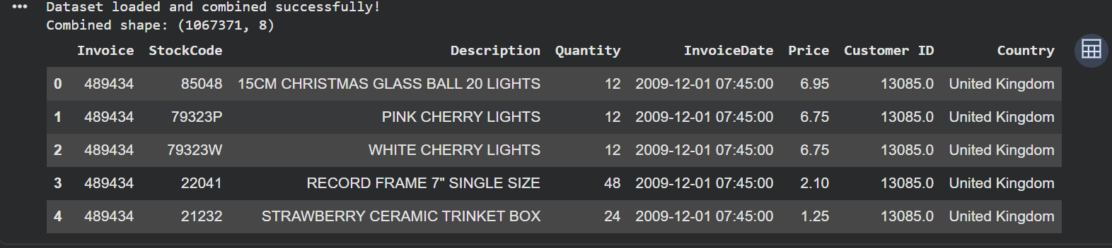

Step 2: Basic Dataset Information
The dataset's shape, column names, and data types were inspected to understand its structure before analysis. The combined dataset contains 1,067,371 rows and 8 columns: Invoice, StockCode, Description, Quantity, InvoiceDate, Price, Customer ID, and Country.
print(df.shape)
print(df.columns.tolist())
print(df.dtypes)
df.info()

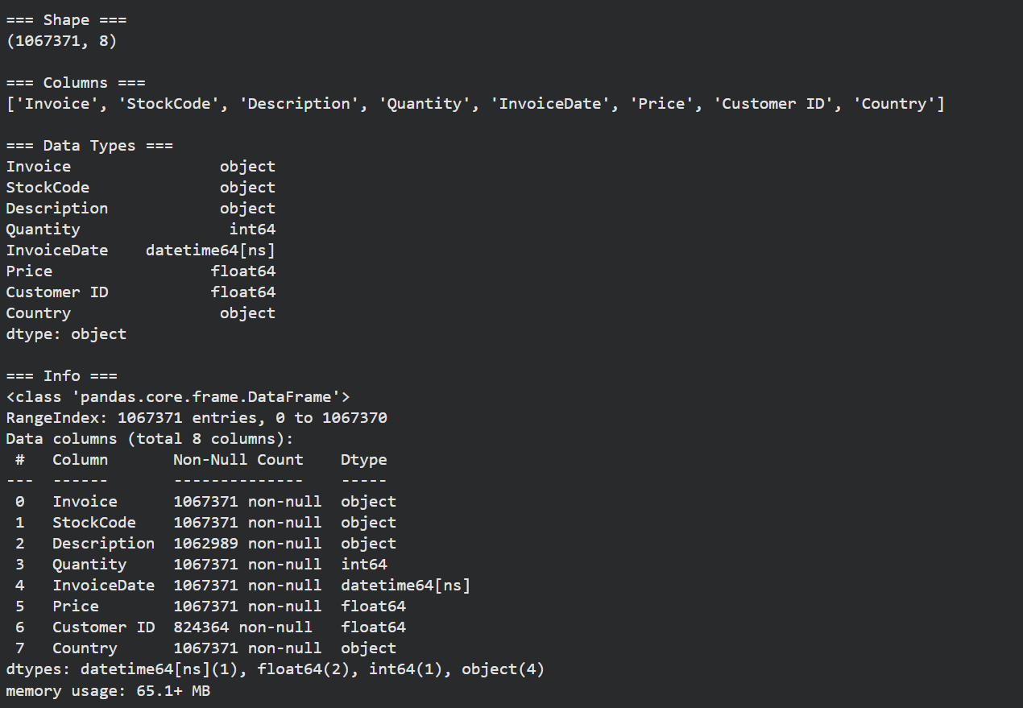

Step 3: Missing Values & Duplicate Rows
Missing values and duplicate rows were identified and reported without removing any data, as per task instructions. The Description column had 4,382 missing values (0.41%), and Customer ID had 243,007 missing values (22.77%). Additionally, 34,335 duplicate rows (3.22%) were found in the dataset.
missing = df.isnull().sum()
missing_pct = (missing / len(df)) * 100
print(missing_df[missing_df['Missing Count'] > 0])

duplicate_count = df.duplicated().sum()
print(f"Total duplicate rows: {duplicate_count}")

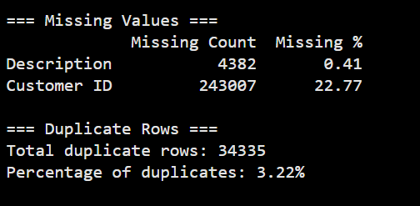

Step 4: Top 10 Best-Selling Products
A Revenue column was created (Quantity × Price), and the top 10 products were identified separately by total quantity sold and by total revenue generated. This highlights which products drive the most volume versus the most income.
df['Revenue'] = df['Quantity'] * df['Price']

top10_qty = df.groupby('Description')['Quantity'].sum().sort_values(ascending=False).head(10)
top10_rev = df.groupby('Description')['Revenue'].sum().sort_values(ascending=False).head(10)

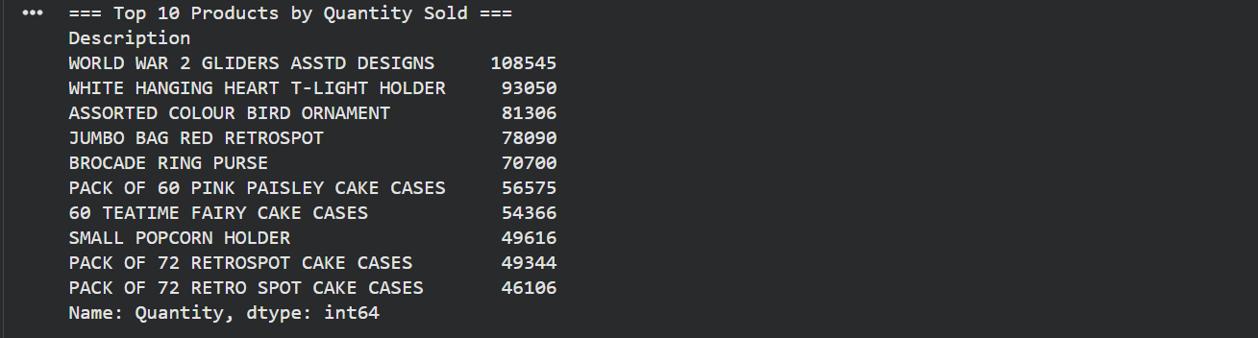
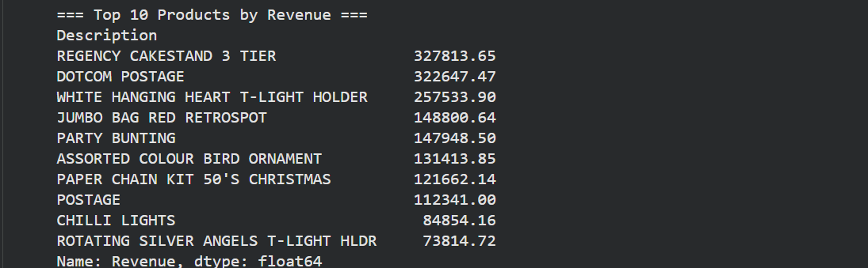

Step 5: Sales Performance by Country
Total revenue was aggregated by country to identify the company's strongest markets. The United Kingdom was found to be overwhelmingly dominant, contributing approximately 84.94% of total revenue, followed by EIRE, Netherlands, Germany, and France.
country_sales = df.groupby('Country')['Revenue'].sum().sort_values(ascending=False).head(10)
print(country_sales)

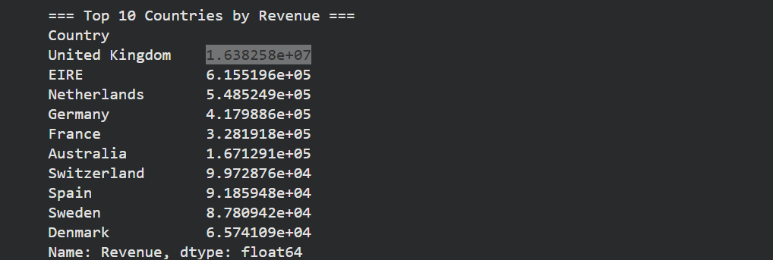

Step 6: Monthly Revenue Trend
Revenue was grouped by month to observe trends over time. This revealed seasonal fluctuations in customer purchasing behavior, with a noticeable increase in revenue toward the end of the year, consistent with holiday shopping demand.
df['InvoiceMonth'] = df['InvoiceDate'].dt.to_period('M')
monthly_revenue = df.groupby('InvoiceMonth')['Revenue'].sum()
monthly_revenue.plot(kind='line', marker='o')

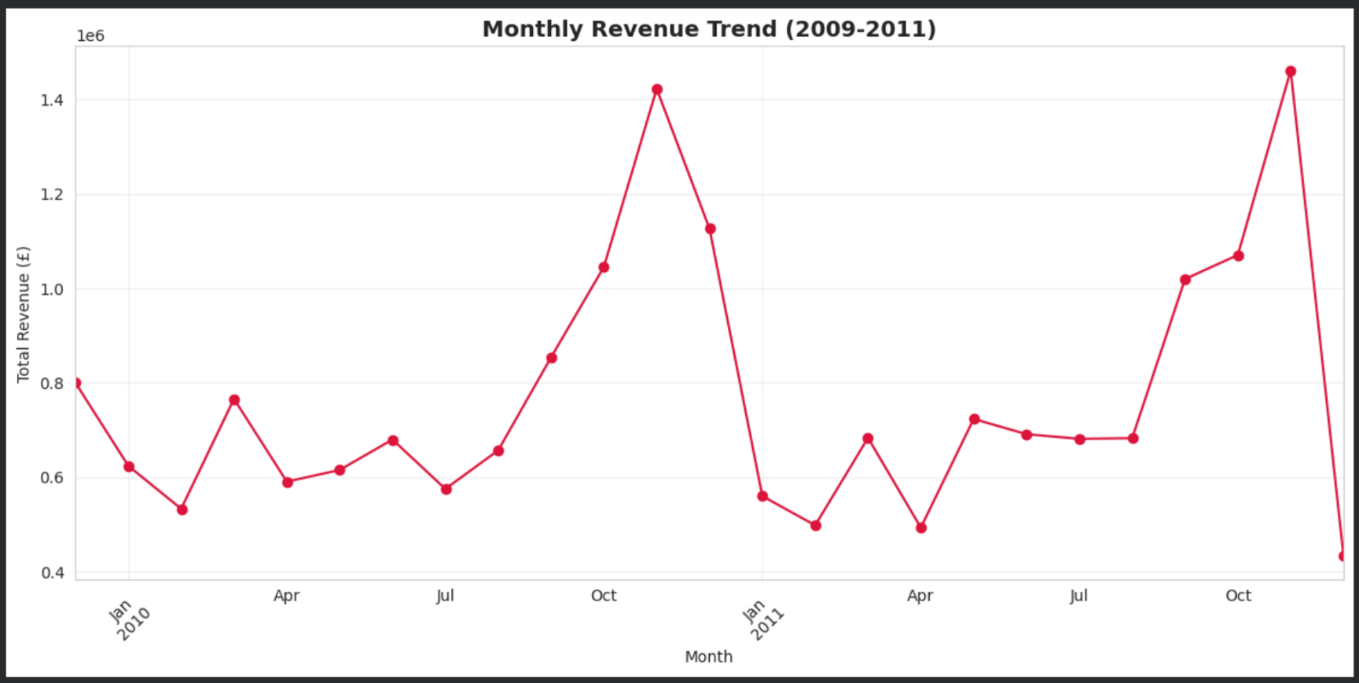

Step 7: Correlation Heatmap
A correlation heatmap was created to examine relationships between Quantity, Price, and Revenue. Revenue showed a stronger correlation with Quantity than with Price, indicating that sales volume — rather than unit price — is the primary driver of total revenue.
numeric_cols = df[['Quantity', 'Price', 'Revenue']]
corr = numeric_cols.corr()
sns.heatmap(corr, annot=True, cmap='coolwarm', fmt='.2f')

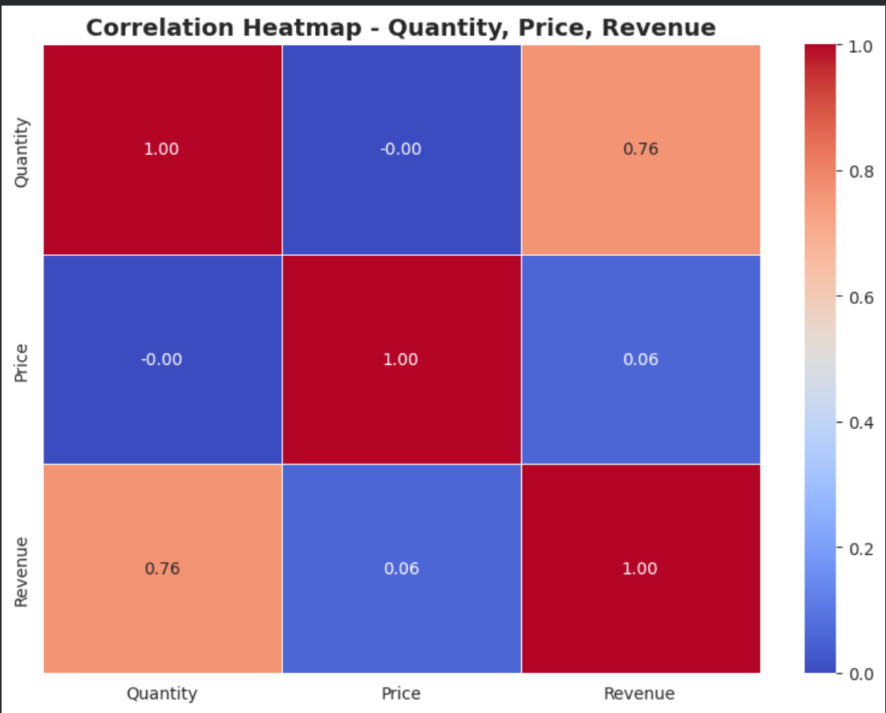

Step 8: Outlier Detection (Box Plots)
Box plots were used to visually detect outliers in Quantity, Price, and Revenue. The Interquartile Range (IQR) method was also applied to quantify the number of outliers in each column. Negative Quantity values were observed, corresponding to order cancellations (Invoice numbers starting with 'C'), which are legitimate business events rather than data errors.
for col in ['Quantity', 'Price', 'Revenue']:
Q1 = df[col].quantile(0.25)
Q3 = df[col].quantile(0.75)
IQR = Q3 - Q1
outliers = df[(df[col] < Q1 - 1.5*IQR) | (df[col] > Q3 + 1.5*IQR)]
print(f"{col}: {len(outliers)} outliers detected")

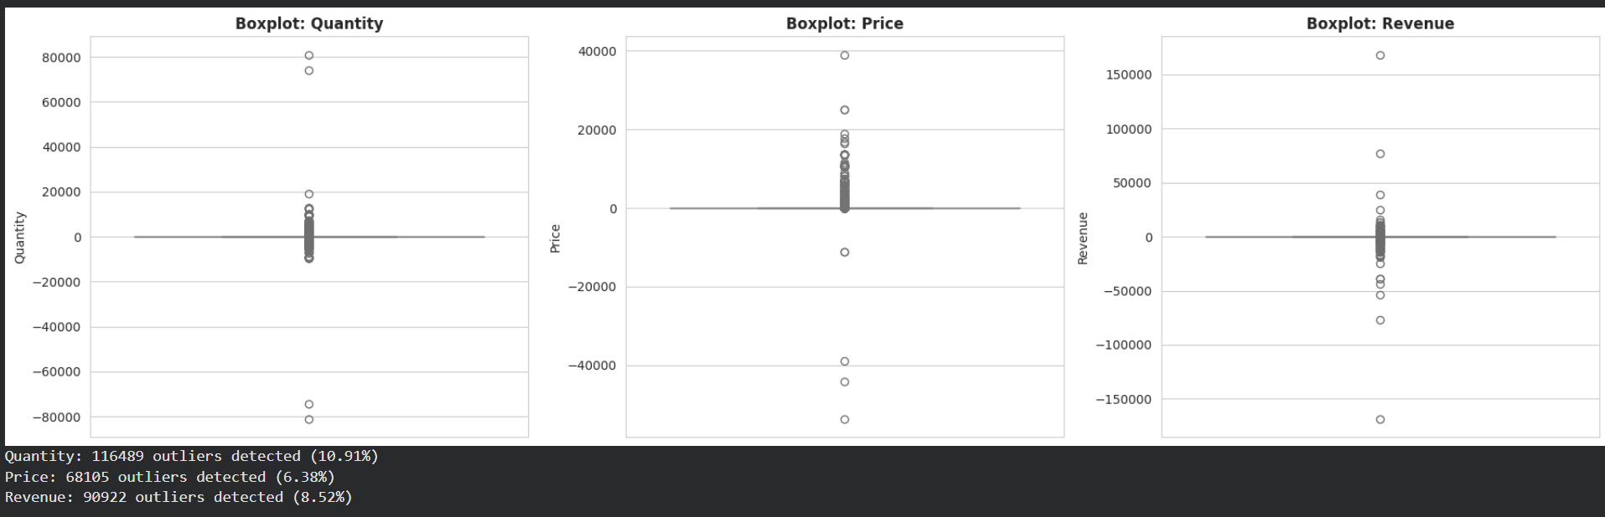

Business Insights
Based on the exploratory data analysis, the following key business insights were derived:
- Revenue is heavily concentrated in one market: The United Kingdom contributes roughly 84.94% of total revenue, showing strong dependence on a single country. The business should consider expanding marketing in the next-highest revenue countries (e.g., EIRE, Netherlands, Germany, France) to diversify and reduce geographic risk.
- A small set of products drives a large share of revenue: The top 10 best-selling products account for a disproportionately large share of total revenue relative to the size of the full product catalog. Prioritizing stock availability and promotion for these high performers could improve overall sales efficiency.
- Sales show a clear seasonal pattern: Monthly revenue rises sharply toward November–December, indicating strong holiday-driven demand. The company should plan inventory, staffing, and marketing campaigns in advance of this peak season each year.
- Missing customer data limits personalization potential: About 22.77% of transactions have no Customer ID, meaning a significant portion of sales cannot be linked to a specific customer. This is a key data-quality gap that must be addressed before building a reliable recommendation system.
- Negative quantities reflect returns, not data errors: A portion of records show negative Quantity values, corresponding to cancelled orders (Invoice numbers starting with 'C'). These represent real returns/cancellations and should be treated as a separate category in future analysis rather than treated as noise or removed.

